Unlocking the Power of Big Data

MADSC102-MUC07313

TANSU TOSUN
Student ID: 25047754

CONTENTS

Data INGESTION (4.1)
DATA PREPERATION & DATA ANALYTICS (4.2)
DATA STORAGE (4.3)
SQL QUERIES (4.4)
NOTEBOOK ANALYSIS (4.5)
DASHBOARDS (4.6)
REGRESSION (Machine Learning Component A small ML model such as: • Regression)

DATA INGESTION (4.1)

- For Final Exam exercises I selected SnowFlake DB. I was more familiar to that tool in my previous Professional life.
Firstly the account is generated.

- A dataset named Credit is loaded to SnowFlake environment.
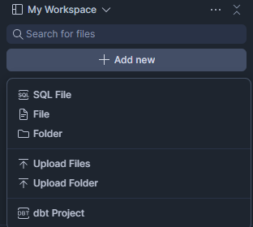

- The dataset related with Credit processes is uploaded to the data. It is uploaded to the database named as “TANSU” and schema is named as “PUBLIC”

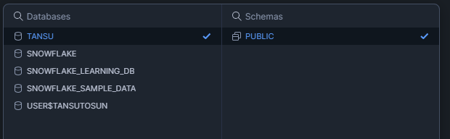
- For testing I wrote the following sql script to Show the data in the interface.
SELECT *
FROM
"TANSU"."PUBLIC"."CREDIT" LIMIT 10 ;

DATA PREPERATION & DATA ANALYTICS (4.2)

- We will make an analysis and find some outputs. But to execute this target our data should be clean. In the dataset 25 variables. I selected some important variables and make an investigation to find person income
Income = α + β1*Cash Amount + β2* BUREAU Score + β3*AGE + β4*TMJOB1

To understand data convenience for analysis the tables and chart properties are used in software.

Firstly, we analysed Cash Amount. It seems we do not have negative numbers. But at the same time, we have outlier values at the right side of the graphic. (Around 105K). This number will be excluded in the sql to have a stable data.

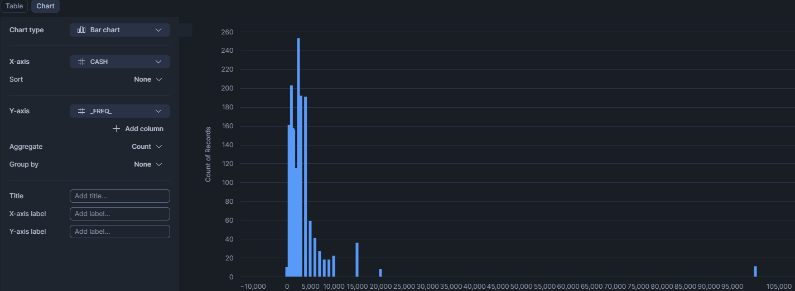

- Another variable we analysed is BUREAU SCORE
The graph below shows the Bureau Score distribution. Around %65 has 1 (lower score), %1-2 for mid Score and %33-34 has higher score.

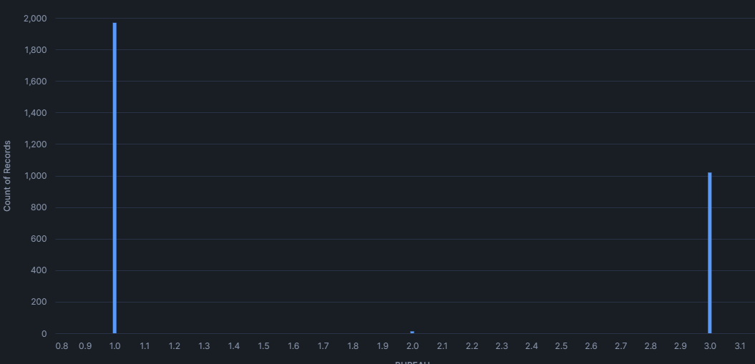

- The third variable in the dataset is age. When we check the dataset, the graph shows that all ages are over 18 and less than 74. So there is no need for any data cleaning procedure..

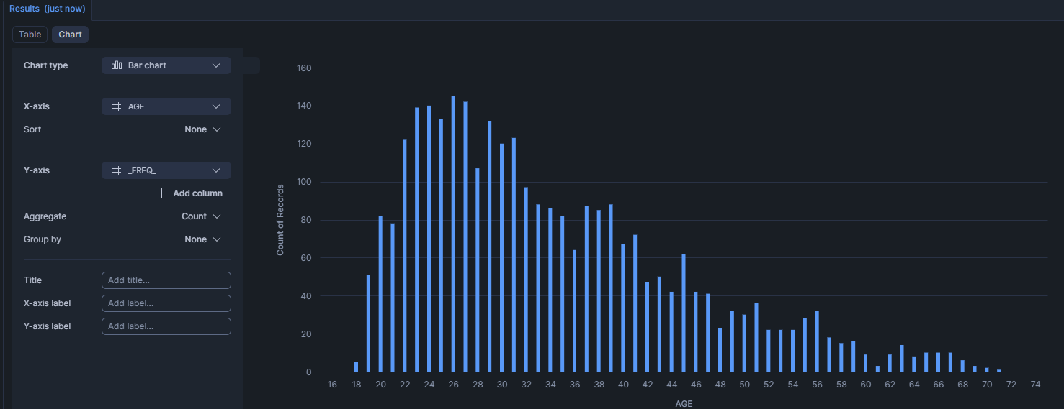

- The forth important variable to show as income predictor is work experience. Now lets check the distribution for data analysis purposes.

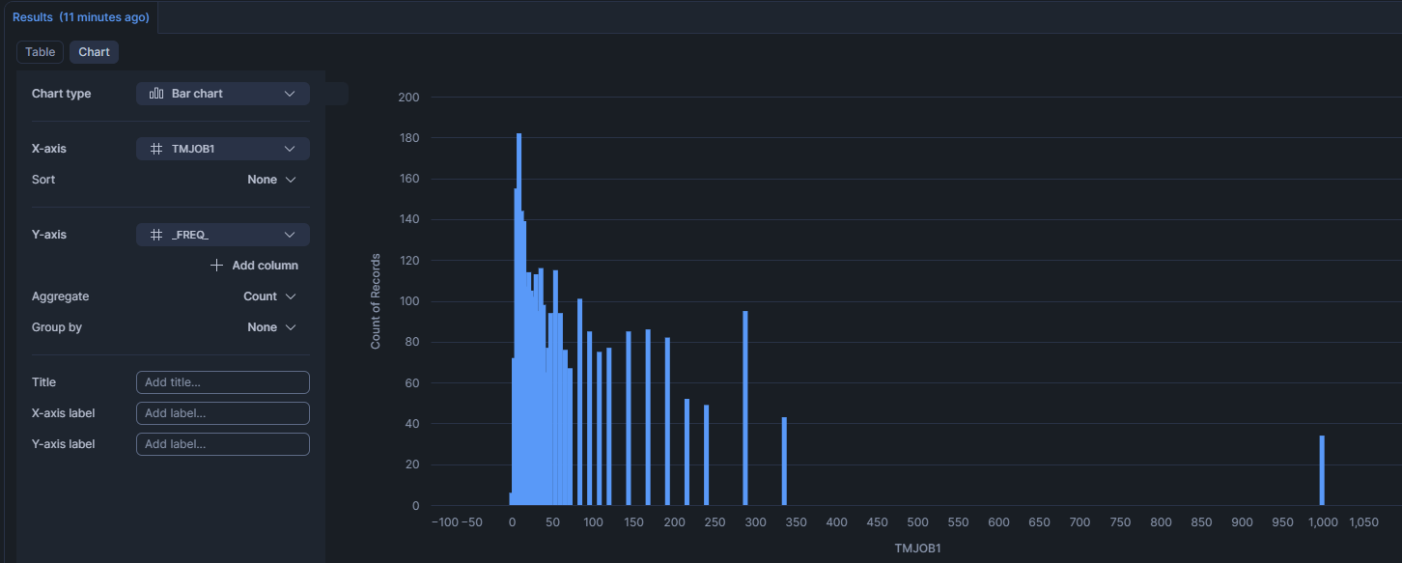

- According to graph generally people have less than 60 months (which means 5 year) professional experience.
To maintain data quality the following rules are applied to cleanse data.
TMJOB1 < 360
CASH <= 20000
The following chart shows the final query result.
We have 2955 records as cleansed data.
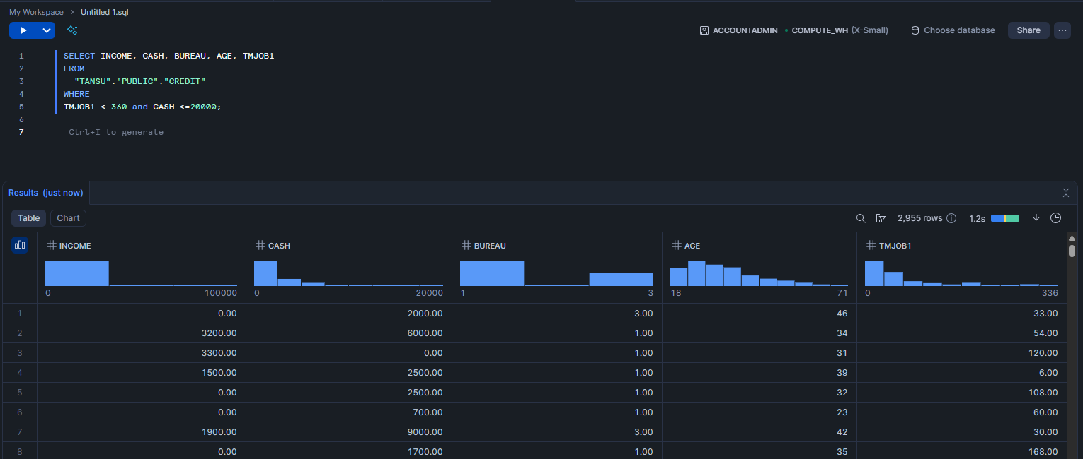

DATA STORAGE (4.3)

- The final cleansed data is stored in database.

Create TABLE "TANSU"."PUBLIC"."Analyze_08DEC" as
SELECT INCOME, CASH, BUREAU, AGE, TMJOB1
FROM
"TANSU"."PUBLIC"."CREDIT"
WHERE
TMJOB1 < 360 and CASH <=20000;

select * from "TANSU"."PUBLIC"."Analyze_08DEC" ;



SQL QUERIES (4.4)

We will continue with 2 important questions to understand data.
- What is the lowest and highest segment profiles in the dataset?

To answer the question 1 the following sql is run.

Select AVG(INCOME), CASH_BIN, AGE_BIN, BUREAU_BIN, EXPERIENCE_BIN
from "TANSU"."PUBLIC"."Analyze_08DEC_v3"
group by CASH_BIN, AGE_BIN, BUREAU_BIN, EXPERIENCE_BIN
order by AVG(INCOME) desc ;

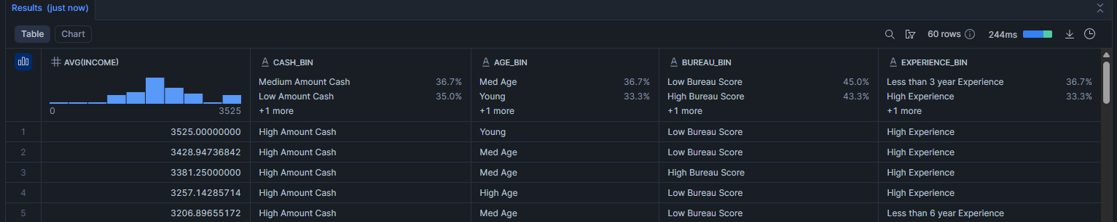

Select AVG(INCOME), CASH_BIN, AGE_BIN, BUREAU_BIN, EXPERIENCE_BIN
from "TANSU"."PUBLIC"."Analyze_08DEC_v3"
group by CASH_BIN, AGE_BIN, BUREAU_BIN, EXPERIENCE_BIN
order by AVG(INCOME);

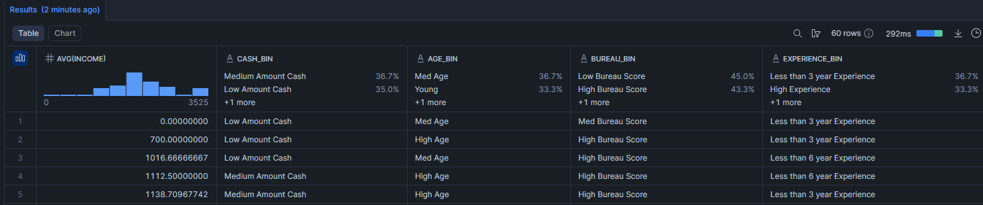

- Is there any insignificant data structure in the collection?
From the queries we easily understand that the following subset has no information regarding income information.
- Low Amount Cash,
- Medium Age,
- Med Bureau Score,
- Less than 3 years of experience.
This profile has information regarding income amount.
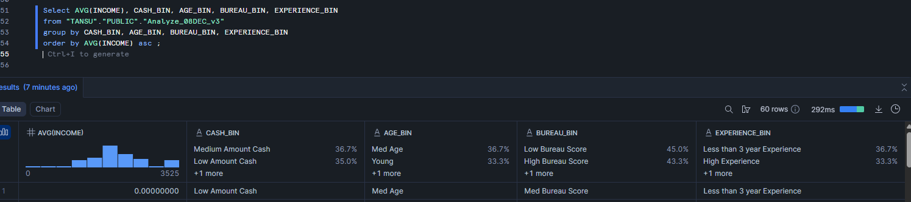

NOTEBOOK ANALYSIS (4.5)
To execute the analysis, Snowflake editor is used. The editor is attached to appendix. But the codes in editor is shared below.
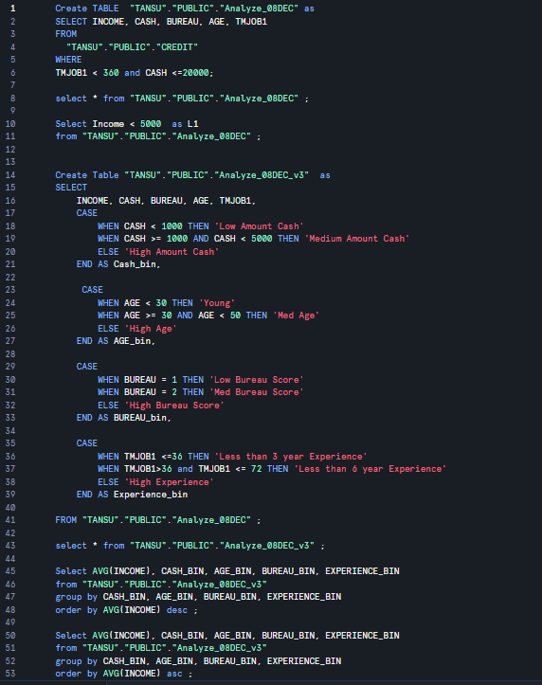

DASHBOARDS (4.6)
The dashboard is generated from the following link.
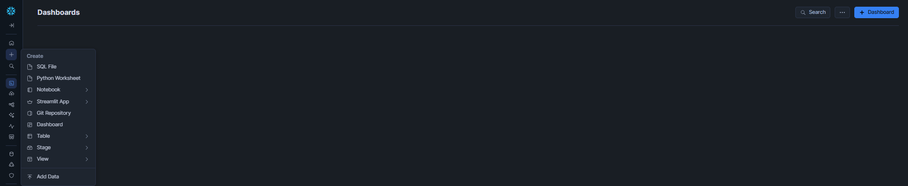
The following graph is generated in Data Snowflake to understand data granularity. It seems there are outlier values in income variable. After 10K value the high amount runs around 100K values.
Dashboard 1
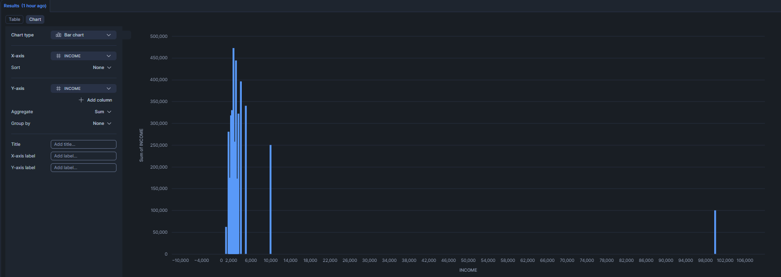

Title: INCOME PROFILING
Y Axis: FREQUENCT OF RECORDS
X Axis: INCOME DISTRIBUTION
FILTER: INCOME > 0
For Dashboard1 the SQL query is as follows:
Filter Command:
SELECT INCOME FROM "TANSU"."PUBLIC"."CREDIT"
where INCOME > 0 ;

Dashboard 2
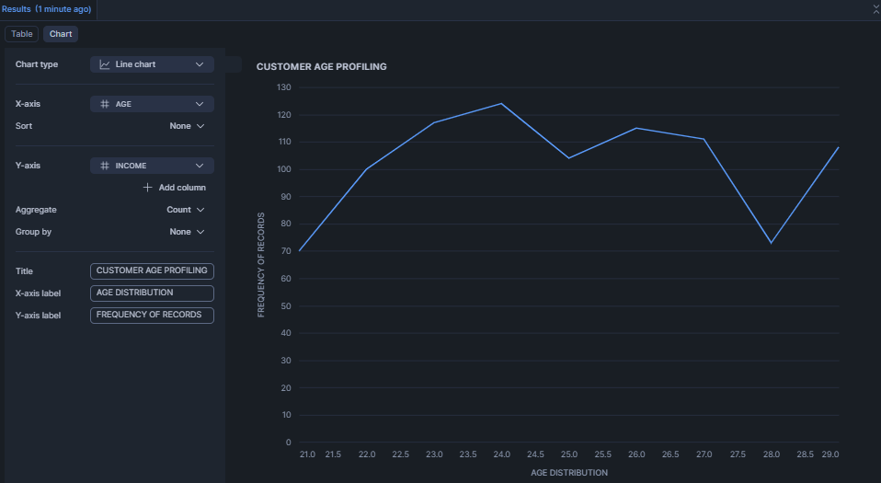
Title: CUSTOMER AGE PROFILING
Y Axis: FREQUENCT OF RECORDS
X Axis: AGE DISTRIBUTION
FILTER: AGE>=22 and AGE<30
From second dashboard it is understandable that from age=22 to from age=32, this 10-year period is the highest segmentation in customer distribution. The dashboards are made using app.snowflake part.
Filter Command:
SELECT INCOME, CASH, BUREAU, AGE, TMJOB1
FROM
"TANSU"."PUBLIC"."CREDIT"
where AGE is not NULL and AGE >20 and AGE <30;

4.7 REGRESSION

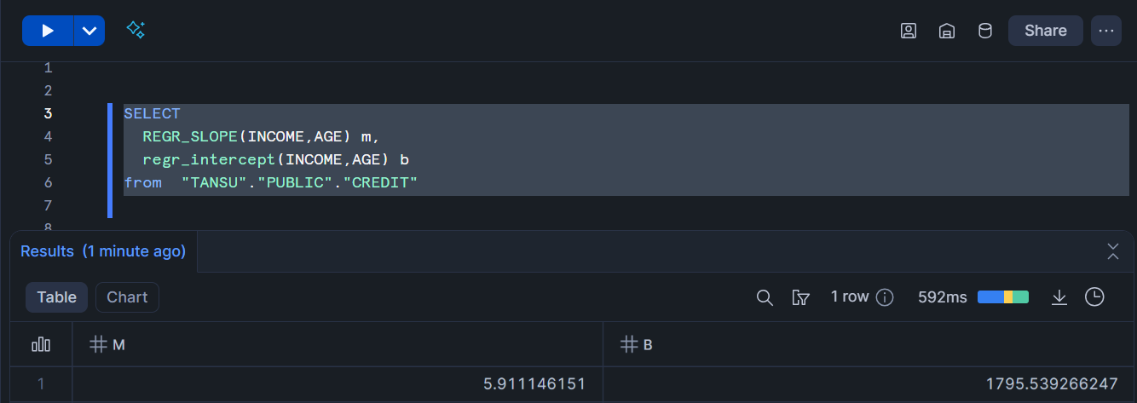

From Regression Equation the final solution is

INCOME = 1795.53 + AGE * 5.91

